Index

- Files and dirs
- Streams and buffers
- Pipes

1. Files (fs module)

The fs module is in charge of supporting the reading and writing of files.
We import it and also create a text file to work with.

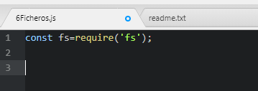
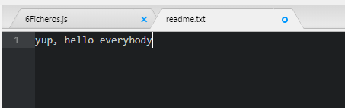
There are two ways to work with files:
- synchronous: while a file is being read or written, the subsequent code execution is paralyzed.
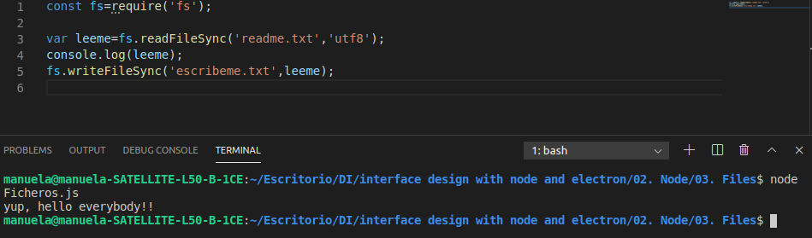

- asynchronous: other processes can continue to run while reading or writing the file. In that case we have to pass a callback function to the readFile and writeFile functions, which will be the one that is executed at the end of the action. This function will take as parameters the error that is thrown if the operation fails and the data that we read or write.

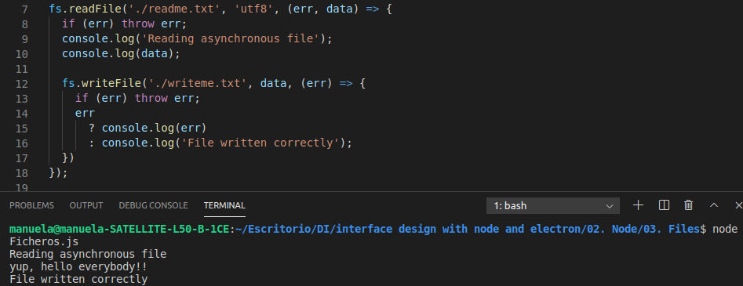

There are more functions available in fs, we can refer to the node documentation
- fs.rename: rename files
- fs.stat: file information
- fs.appendFile; add data asynchronously. Create the file if it doesn't exist.
- fs.unlink: delete a file
fs.unlink ('writeMe.txt', (err) => { if (err) throw err; console.log ('writeMe.txt was deleted'); });
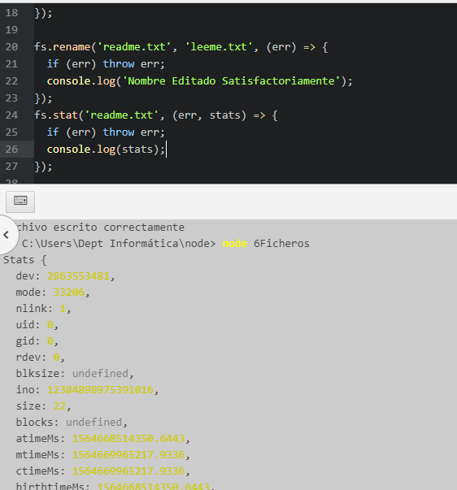
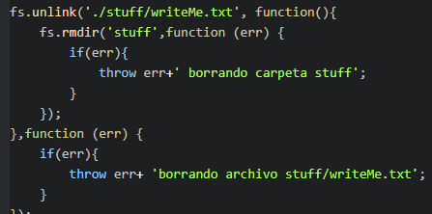

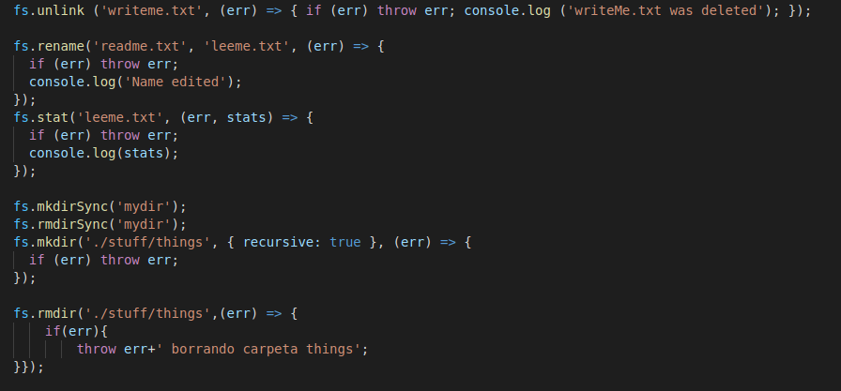
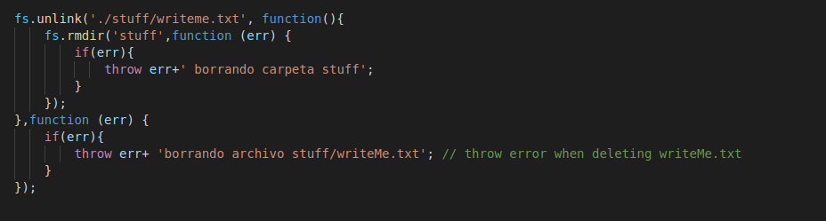

- Streams and Buffers

A buffer is a temporary storage of a piece of data belonging to a much larger data set that is transported from one place to another. The buffer fills with data and is transferred to the final destination.

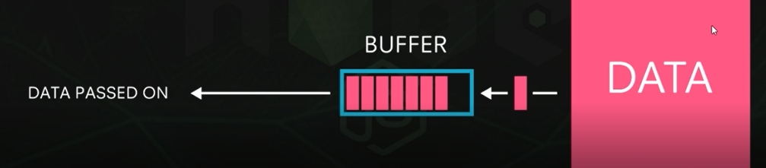
When the buffer is full, this data is transferred through a stream, which would be the channel itself.

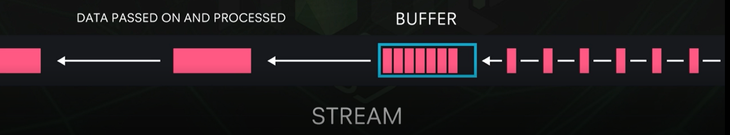
This process occurs, for example, when watching streaming movies: we don't wait for the entire movie to have been transferred to the computer, but rather we visualize the data in these small chunks that are transferred to the buffers.

In node we can create buffers and streams to pass data, which increases the efficiency and performance of the application.

Reading streams

A read stream is used to read a large file for example. Create a file with enough text, for example the story of the ghetto brothers of the bronx.
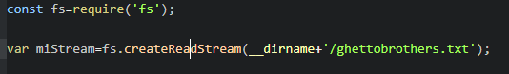

In this variable miStream, bits of the file that have been stored in the buffer would be stored.

createReadStream inherits from EventEmitter and has an event called data that is fired every time the stream fills up so we're going to use it to see the chunks themselves.

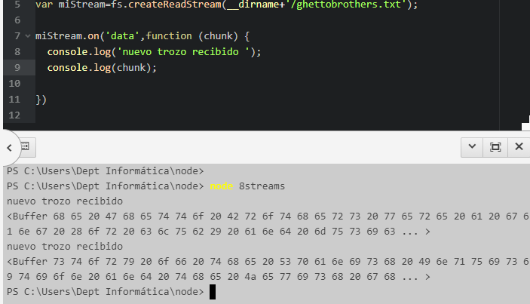
If instead of seeing it in hexadecimal we want to see the text itself, we add the encoding

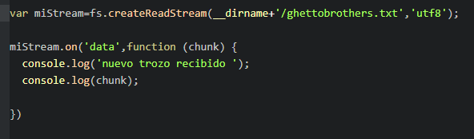
To control the buffer size for example 1 bytes

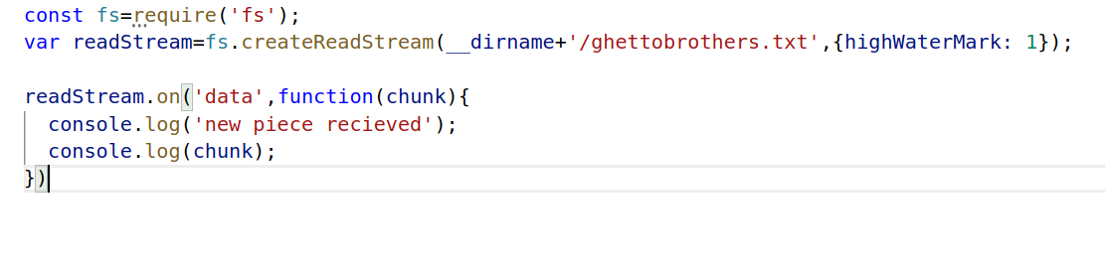

Each piece of data would be capable of being passed to the client with a write stream instead of waiting to have the whole file.

Write stream

Typically we will want to pass the buffered data to a file or client, not just display it on the console. For this we need a writing stream. To create one that writes to a file:

Every time a chunk of data arrives we will write it to this new file.

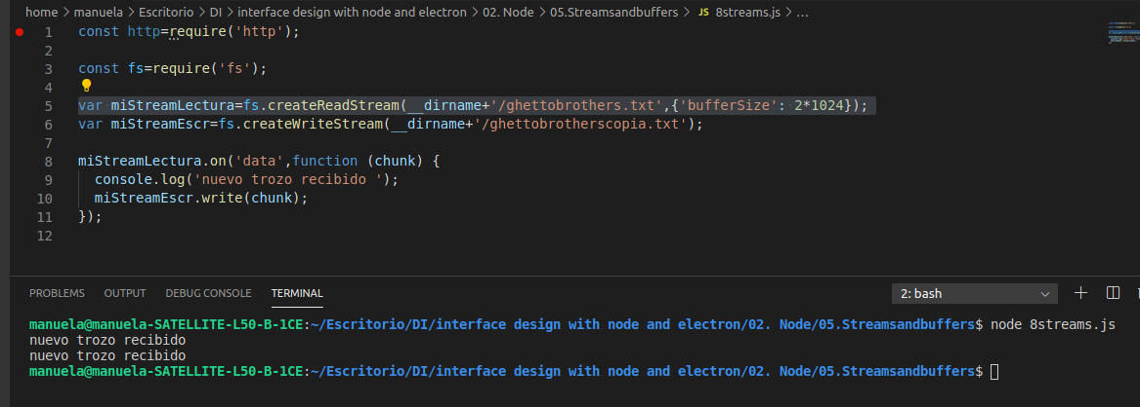
The difference between this method and the readFile writeFile that we did previously is that in this case the data can be used as it reaches its destination, and it is much faster. There is an even faster way to do it: pipes.

- Pipes

The pipeline saves us the trouble of "listening" manually when a piece of data has arrived to be written to the writing stream, it does so automatically.

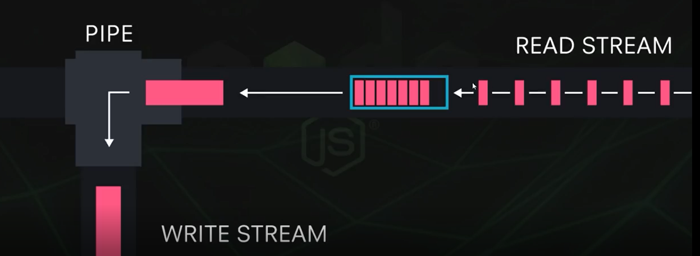
The above code is simplified using the pipe method of readable stream

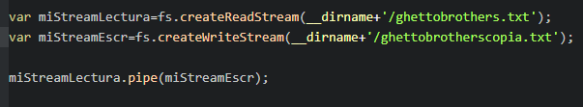
We are going to use this idea to send data to a client using the server we created days ago, sending him the Ghetto Brothers file so that he can learn about urban culture. For this, instead of making the output of the pipe a writeable stream, we make it the client's response.
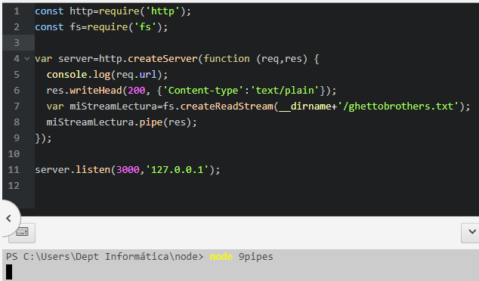

In the browser:

It is displayed in text mode because the default encoding is utf8.

If we want to send an html file like for example

We have to change the type of text that is sent so that the browser treats the file as html and not plain text

res.writeHead(200, {'Content-type':'text/html'});

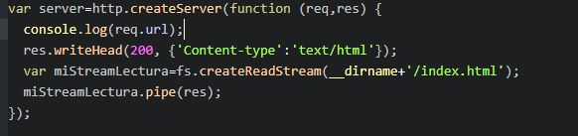
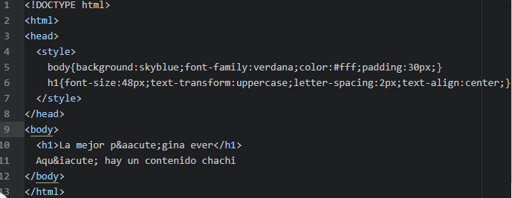
in the browser

